**DAY – 5 TASK(Functions)**

Batch – BD30

Name -- Jayadev

1. **Do the below programs in arrow functions**
   1. **Print odd numbers in an array**

**Code:**

let num = ["1","2","3","4","5","6","7","8","9","10"]

let compute =(num)=>{

  for(i=0;i<num.length;i++)

  {

  if((num[i] % 2 ) === 0)

  {

  console.log(num[i]);

}

  }

}

compute(num);

**output:**

2

script.js:7 4

script.js:7 6

script.js:7 8

script.js:7 10

(index):40 Live reload enabled.

:5500/favicon.ico:1 Failed to load resource: the server responded with a status of 404 (Not Found)

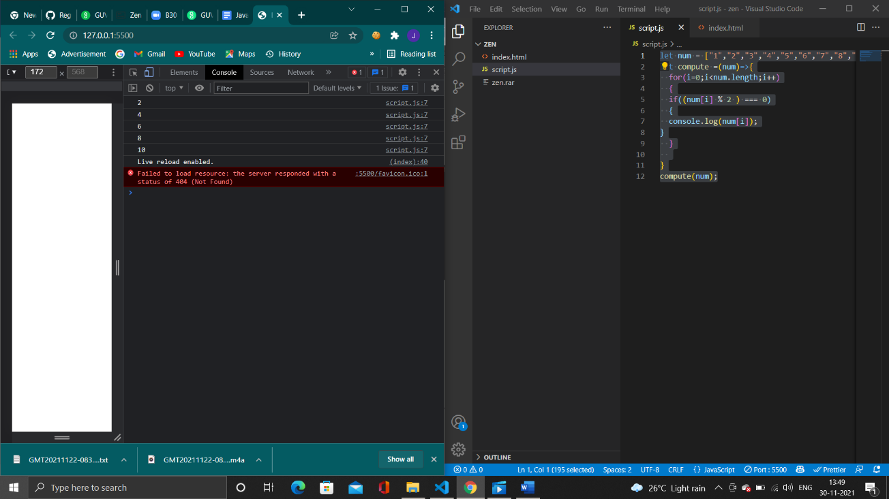

* 1. **Convert all the strings to title caps in a string array**

**Code:**

let str = "i'm a little tea pot"

let compute =(str)=>{

  str = str.toLowerCase().split(' ');

  for (var i = 0; i < str.length; i++) {

    str[i] = str[i].charAt(0).toUpperCase() + str[i].slice(1);

  }

  console.log(str.join(' '));

}

compute(str);

**output:**

I'm A Little Tea Pot

(index):40 Live reload enabled.

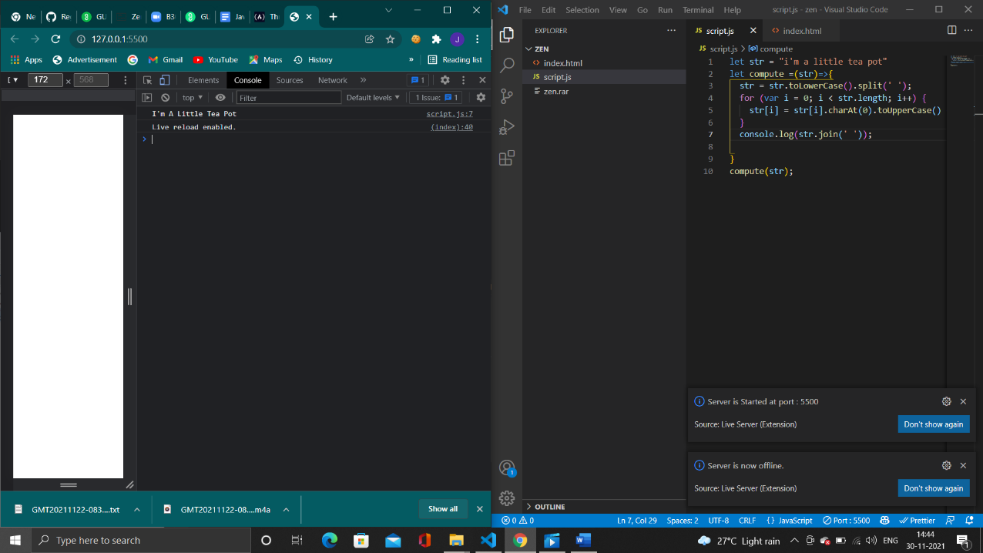

* 1. **Sum of all numbers in an array**

**Code:**

let str = [1,2,3,4,5]

let sum = 0

let compute =(str)=>{

  for (var i = 0; i < str.length; i++) {

    sum = sum + str[i];

  }

  console.log(sum);

}

compute(str);

**output:**

15

(index):40 Live reload enabled.

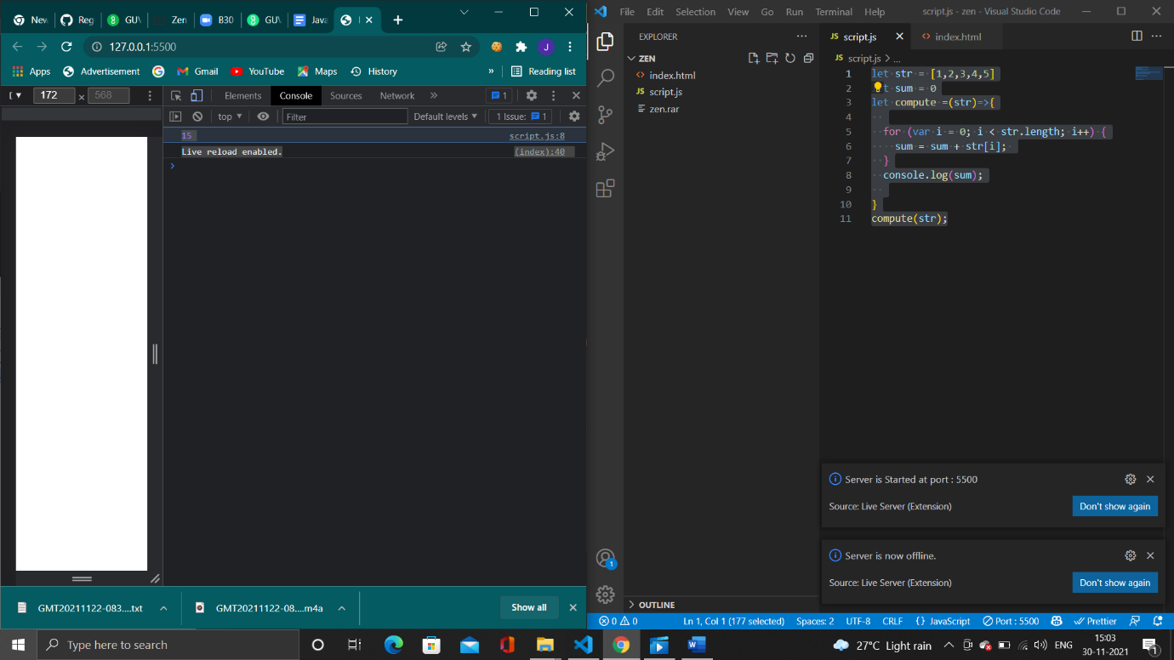

1. **Return all the palindromes in an array**

**Code:**

const arr = ['madam', 4144, 12321,'malayalam'];

const isPalindrome = el => {

   const str = String(el);

   let i = 0;

   let j = str.length - 1;

   while(i < j) {

      if(str[i] === str[j]) {

         i++;

         j--;

      }

      else {

         return false;

      }

   }

   return true;

};

const findPalindrome = arr => {

   return arr.filter(el => isPalindrome(el));

};

console.log(findPalindrome(arr));

**output**

Array(3)0: "madam"1: 123212: "malayalam"length: 3[[Prototype]]: Array(0)

(index):40 Live reload enabled. 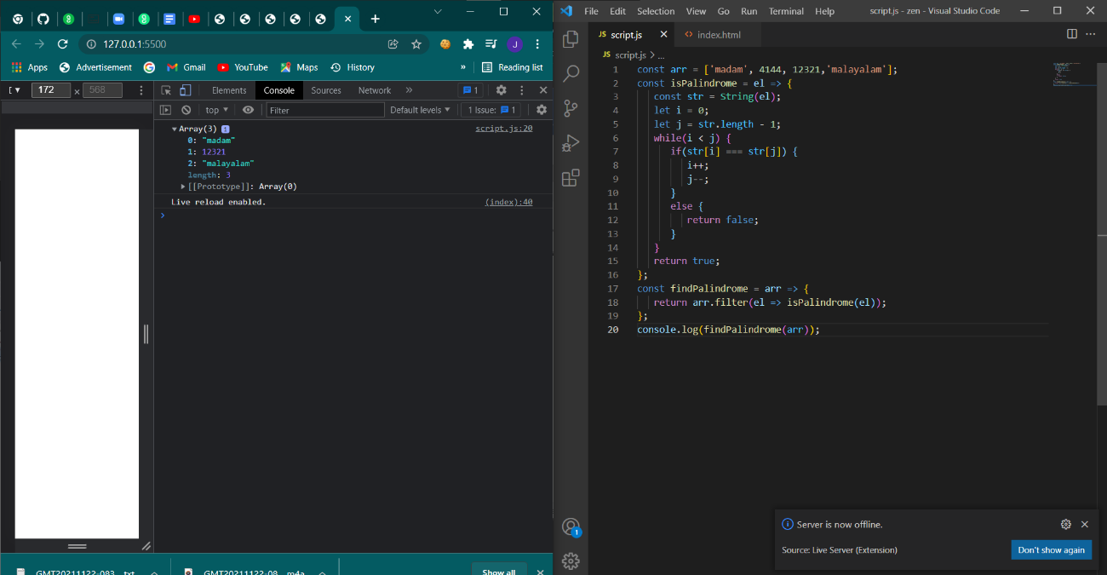

1. **Do the below programs in anonymous function & IIFE**
2. **Print odd numbers in an array**

**Code**:

(function()

{

let arr = [1, 2, 3, 4, 5, 6, 7, 8, 9, 10, 11, 12]

let odds = arr.filter(n => n % 2)

console.log(odds)

}

)();

**Output**:

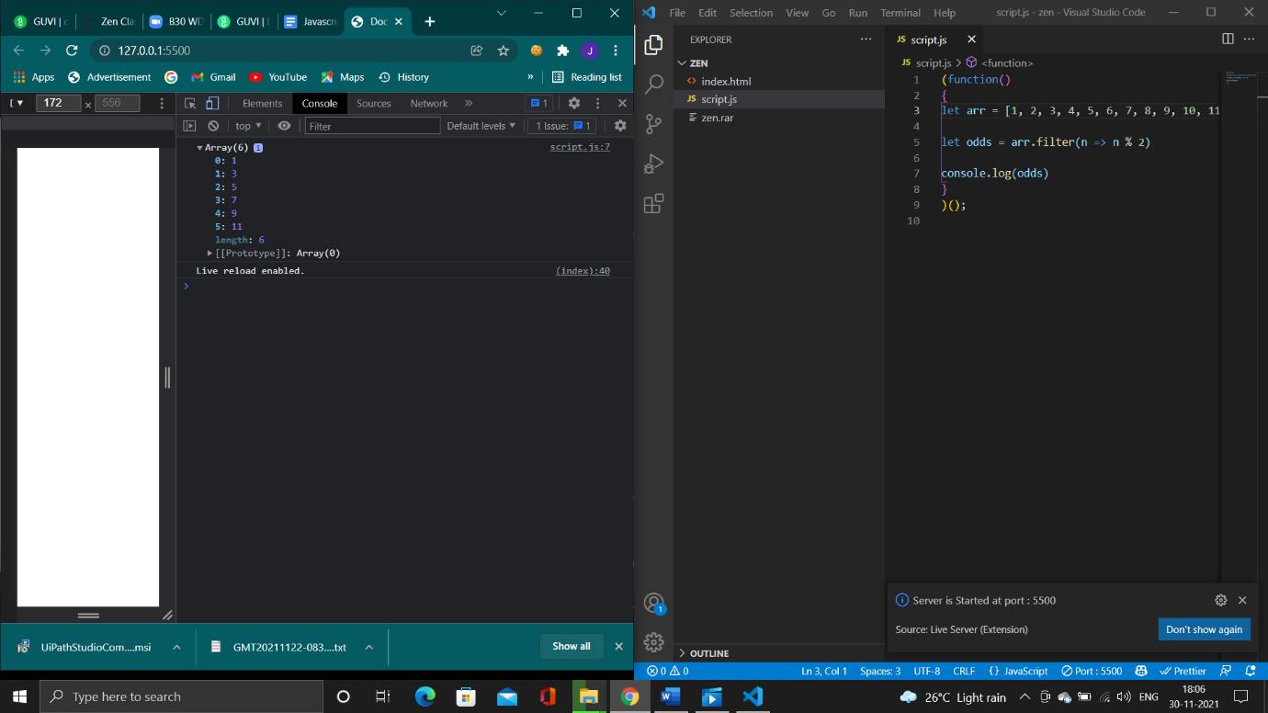

1. **Convert all the strings to title caps in a string array**

**Code:**

(function()

{

   let str = "i'm a little tea pot"

  str = str.toLowerCase().split(' ');

  for (var i = 0; i < str.length; i++)

   {

    str[i] = str[i].charAt(0).toUpperCase() + str[i].slice(1);

  }

  console.log(str.join(' '));

}

)();

**Output:**

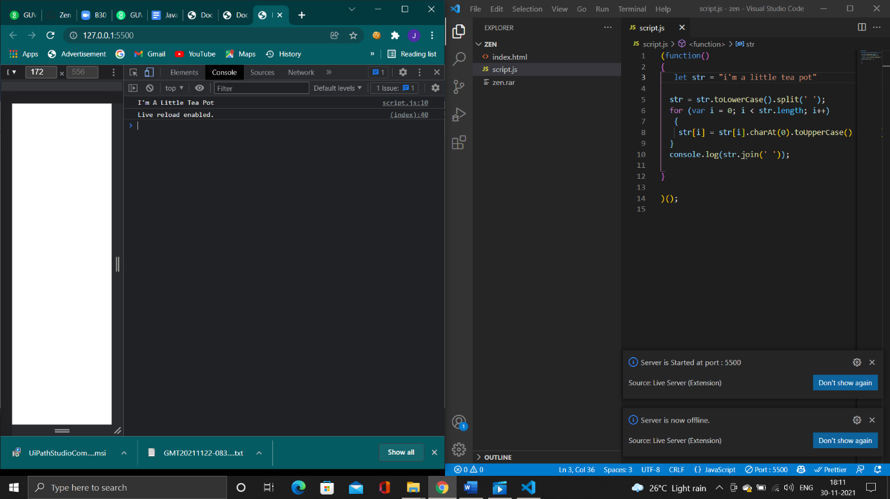

1. **Sum of all numbers in an array**

**Code:**

(function()

{

   let str = [1,2,3,4,5]

let sum = 0

  for (var i = 0; i < str.length; i++) {

    sum = sum + str[i];

  }

  console.log(sum);

}

)();

**Output:**

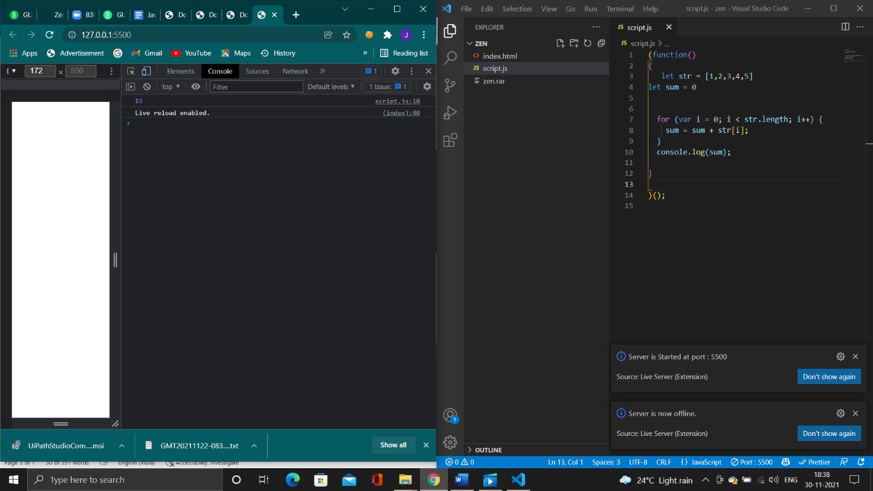

1. **Return all the palindromes in an array**

**Code:**

(function(){

   const arr = ['madam', 4144, 12321,'malayalam'];

const isPalindrome = el =>

 {

   const str = String(el);

   let i = 0;

   let j = str.length - 1;

   while(i < j) {

      if(str[i] === str[j]) {

         i++;

         j--;

      }

      else {

         return false;

      }

   }

   return true;

};

const findPalindrome = arr => {

   return arr.filter(el => isPalindrome(el));

};

console.log(findPalindrome(arr));

}

)();

**Output:**

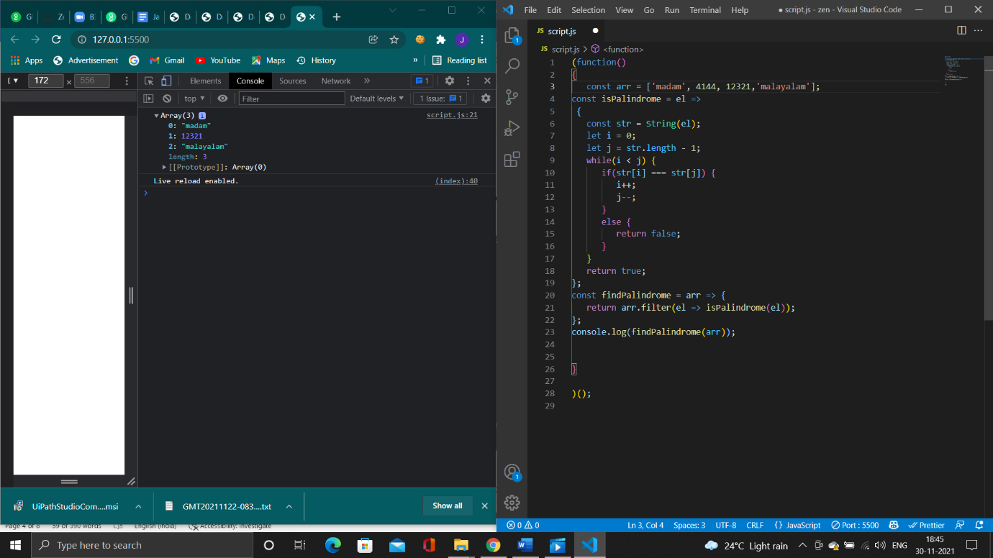

**Remove duplicates from an array**

**Code:**

var abc = function uniq(a) {

      return a.sort().filter(function(item, pos, ary) {

          return !pos || item != ary[pos - 1];

      });

  };

console.log(abc([3, 'q', 'q', 'q', 12, 33, 'q', 13, 'q', 2, 4, 9, 0]));

**Output:**

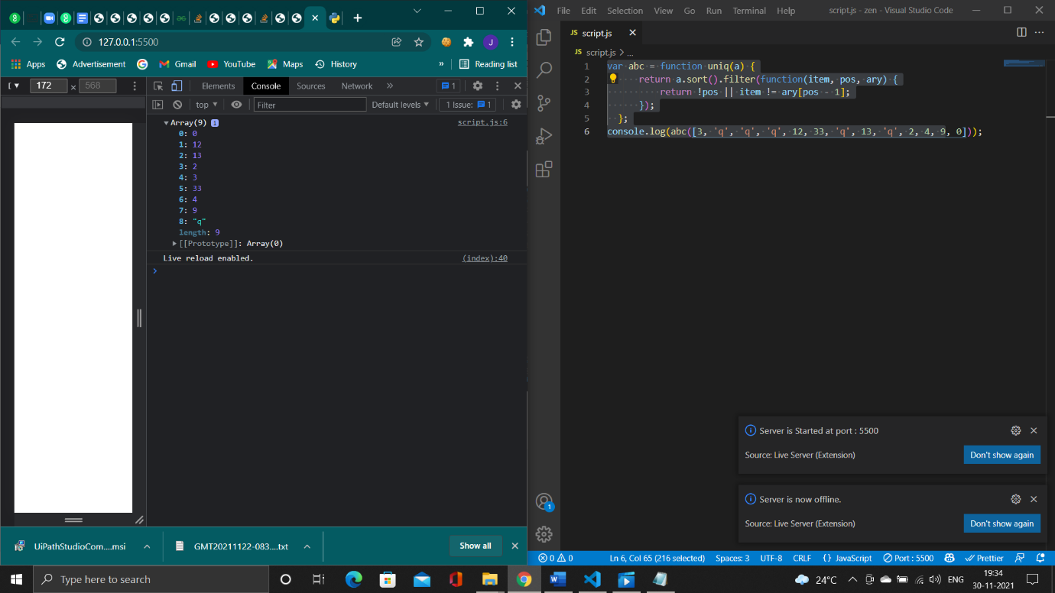

**Rotate an array by k times**

**Code:**

function rotateArray(A, K) {

   if (!A.length) return A;

   let index = 0;

   while (++index < K) {

       A.unshift(A.pop());

   }

   console.log(A);

}

   rotateArray([3, 8, 9, 7, 6], 3)

**Output:**

